- Launch one aws ec2 and install jenkins.
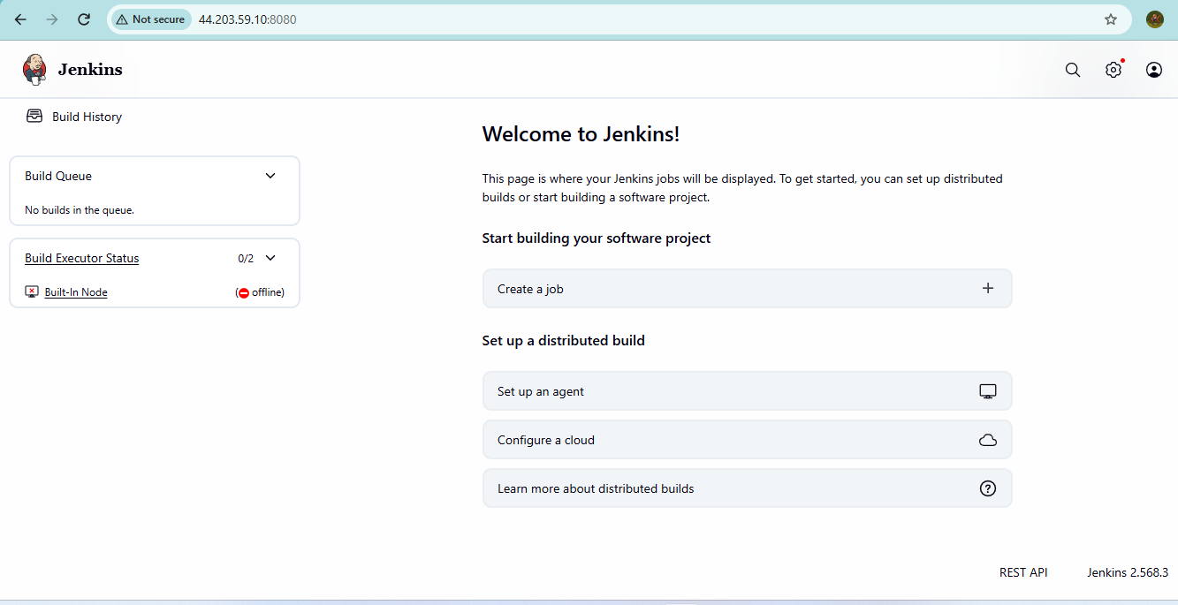

- Setup Apache Tomcat on Ubuntu Virtual Machine
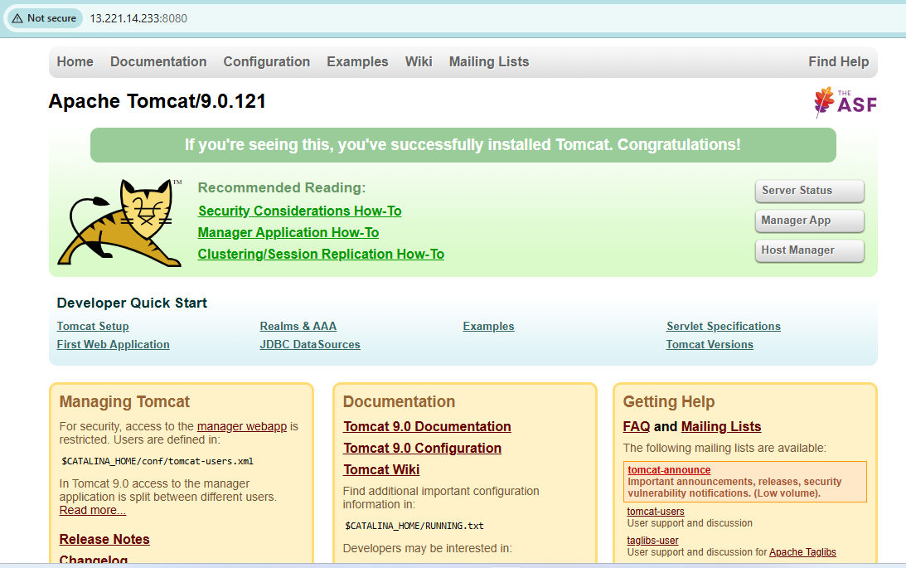

- Setup Docker Desktop on your local windows.
